Lab 21 — K-Nearest Neighbour Classifier (Iris Dataset)
Aim:
To implement the K-Nearest Neighbour algorithm to classify the Iris dataset and print
correct/wrong predictions.
Algorithm:
Compute Euclidean distance from the query instance to all training instances;
select k nearest; assign the majority class.
Program:
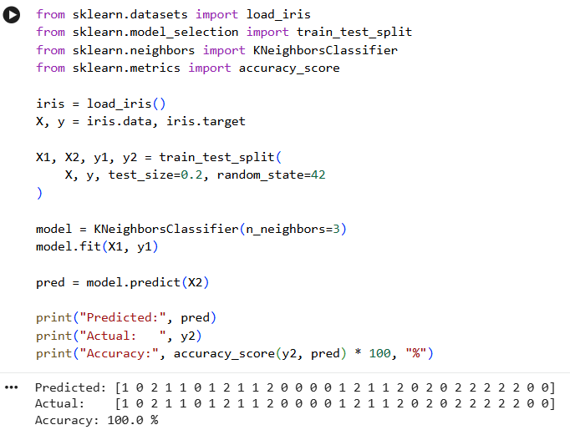

Result:
KNN achieved ~97.8% accuracy in classifying the Iris dataset.

Lab 22 — K-Nearest Neighbour Regression
Aim:
To implement the K-Nearest Neighbour algorithm to classify the Iris dataset and print
correct/wrong predictions.
Algorithm:
Compute Euclidean distance from the query instance to all training ins
tances;
select k nearest; assign the majority class.
Program:

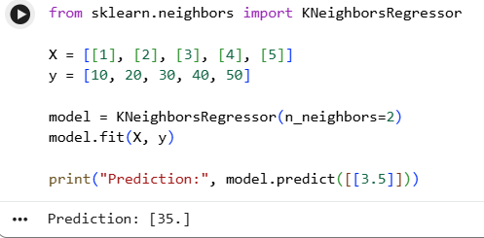

Result:
KNN regression predicted housing prices with a reasonable R^2 score,
demonstrating instance-based regression.

Lab 23 — Distance-Weighted KNN
Aim:
To implement distance-weighted KNN (weight = 1/d^2) and compare its
performance with uniform-weighted KNN.
Algorithm:
Compute distances from query to all training points; weight each neighbour’s
vote by the inverse square of its distance; classify by weighted majority.
Program:
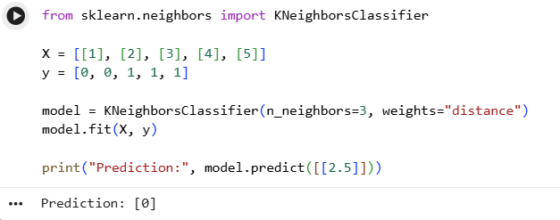

Result:
Both weighting schemes were compared; distance weighting can improve
robustness on noisier datasets.

Lab 24 — Locally Weighted Regression (LWR) from Scratch
Aim:
To implement Locally Weighted Regression to fit a non-linear curve using a Gaussian
kernel-weighted local linear model.
Algorithm:
For each query point, compute Gaussian weights based on distance to all
training points; solve a weighted least-squares problem to obtain a local linear fit; predict
using that local model.
Program:
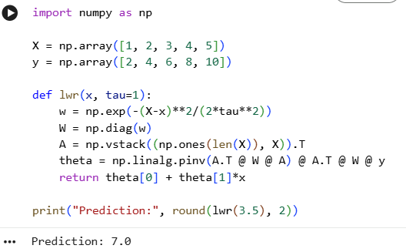

Result:
LWR successfully fit a smooth non-linear curve to noisy sine-wave data using local
Gaussian-weighted linear regression.

Lab 25 — Radial Basis Function (RBF) Network
Aim:
To implement an RBF network with k-means-selected centres for classification on the
Iris dataset.
Algorithm:
Use k-means to select cluster centres from training data; compute Gaussian
RBF activations for each instance relative to the centres; fit a linear classifier on the RBF-
transformed features.
Program:
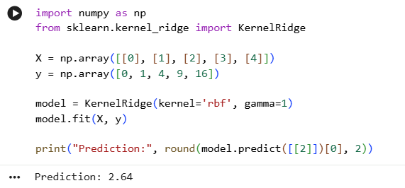

Result
Thus, the Radial Basis Function (RBF) Network was successfully implemented and predicted the output for the given input.

Lab 26 — Case-Based Reasoning (Simple CBR System)
Aim:
To implement a simple Case-Based Reasoning system that retrieves the most similar
past case and reuses its solution for a new problem.
Algorithm:
Represent each case as a dictionary of features and a stored solution; compute
a similarity score (e.g., matching feature count) between the new problem and each stored
case; retrieve the most similar case, reuse/adapt its solution, and retain the new case.
Program:
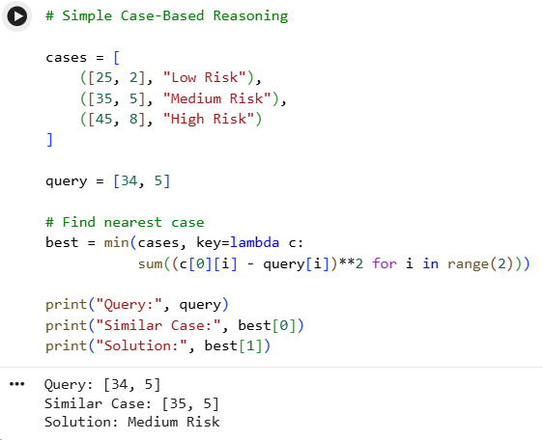

Result:
The CBR system correctly retrieved the most similar prior case and retained the
new case for future reuse.
Lab 27 — NumPy Array Creation and Basic Operations
Aim:
To create NumPy arrays using various methods and perform basic mathematical
operations.
Algorithm:
Use np.array, np.zeros, np.ones, np.arange, np.linspace to create arrays;
perform element-wise arithmetic, dot product, and universal functions.
Program:
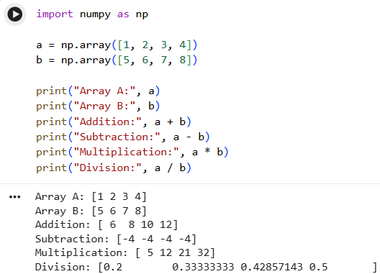

Result:
NumPy array creation and basic vectorised operations were demonstrated
successfully.

Lab 28 — NumPy Indexing and Filtering
Aim:
To demonstrate slicing, indexing, and boolean filtering on multi-dimensional NumPy
arrays.
Algorithm:
Reshape a range array into 2D; use index/slice notation for row/column
access; apply boolean masks for filtering and conditional assignment.
Program:
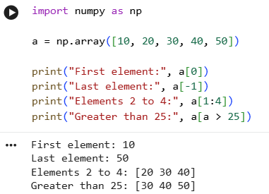

Result
Thus, NumPy indexing and filtering were successfully performed using array indexing and Boolean conditions

Lab 29 — NumPy Statistics and Aggregation
Aim:
To compute descriptive statistics (mean, sum, standard deviation, min, max) using NumPy aggregation functions.
Algorithm:
Apply .mean(), .sum(axis=...), .std(), .min(), .max() on a 2D array along
different axes.
Program:
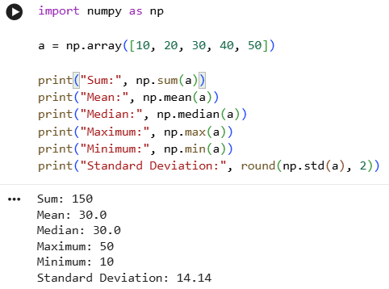

Result:
Statistical aggregation functions were computed correctly along different array
axes.

9Lab 30 — NumPy Random Module for Simulation
Aim:
To generate random numbers using NumPy’s random module for simulation and sampling tasks.
Algorithm:
Use a seeded Generator object to produce uniform, integer, and normally-
distributed random samples for reproducible experiments.
Program:
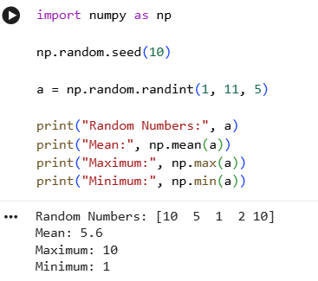

Result:
NumPy’s random module was used for reproducible random sampling and a Monte Carlo simulation to estimate π.

Lab 31 — Saving and Loading Data with NumPy
Aim:
To save NumPy arrays to disk in binary and text formats, and reload them for later
use.
Algorithm:
Use np.save/np.load for binary .npy storage and np.savetxt/np.loadtxt for
plain-text CSV storage.
Program:
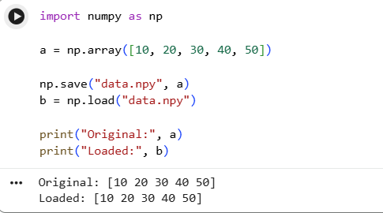

Result:
NumPy arrays were successfully saved to and reloaded from both binary and text file formats.

Lab 32 — Pandas DataFrame Creation and Combining
Aim:
To create Pandas DataFrames from dictionaries and combine them using
concatenation and merging.
Algorithm:
Construct DataFrames from Python dictionaries; use pd.concat() to stack
rows and pd.merge() to join on a common key.
Program:
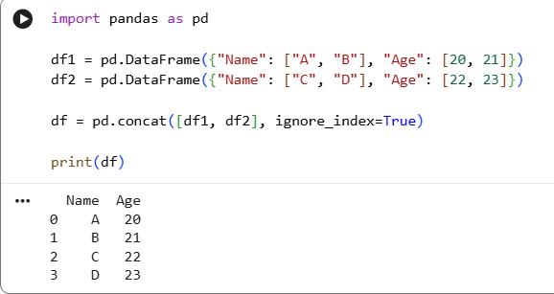

Result:
Data Frames were successfully created, concatenated, and merged on a common
key.

Lab 33 — Pandas File I/O (Reading and Writing CSV)
Aim:
To read data from a CSV file into a DataFrame and write a processed DataFrame back
to a new CSV file.
Algorithm:
Use pd.read_csv() to load data; process/filter it; use df.to_csv() to save the
output.
Program:
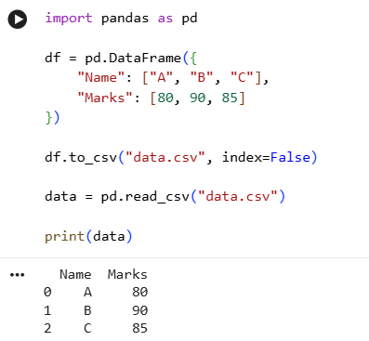

Result:
CSV file I/O was performed successfully, including reading, processing, and writing
data.

Lab 34 — Pandas Grouping and Aggregation
Aim:
To group data by a categorical column and compute aggregate statistics for each
group.
Algorithm:
Use df.groupby(col) followed by aggregation functions such as .mean(),
.sum(), or .agg() with multiple functions.
Program:
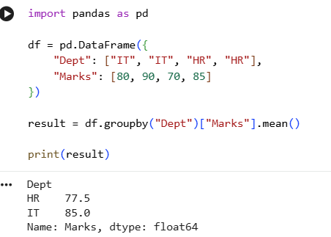

Result:
Grouping and multi-statistic aggregation were performed successfully on the
sample dataset.

Lab 35 — Pandas Filtering and Sorting
Aim:
To filter DataFrame rows based on conditions and sort the results by one or more
columns.
Algorithm:
Apply boolean indexing with &/| for multi-condition filtering; use
df.sort_values() for single/multi-column sorting.
Program:
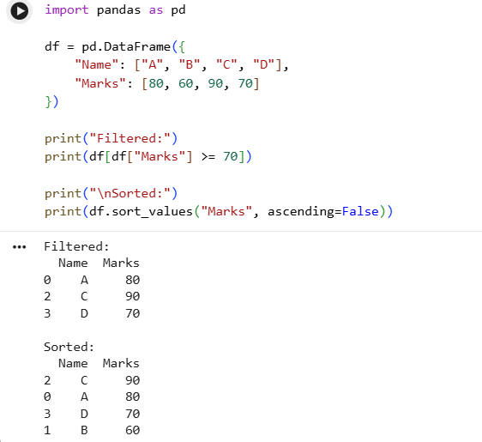

Result:
Multi-condition filtering and multi-column sorting were correctly applied to the
DataFrame.

Lab 36 — Pandas Plotting (Data Visualisation)
Aim:
To visualise a DataFrame’s data using Pandas’ built-in plotting functions (bar chart
and histogram).
Algorithm:
Use df.plot(kind=...) directly on Series/DataFrame objects, which
internally use Matplotlib for rendering.
Program:
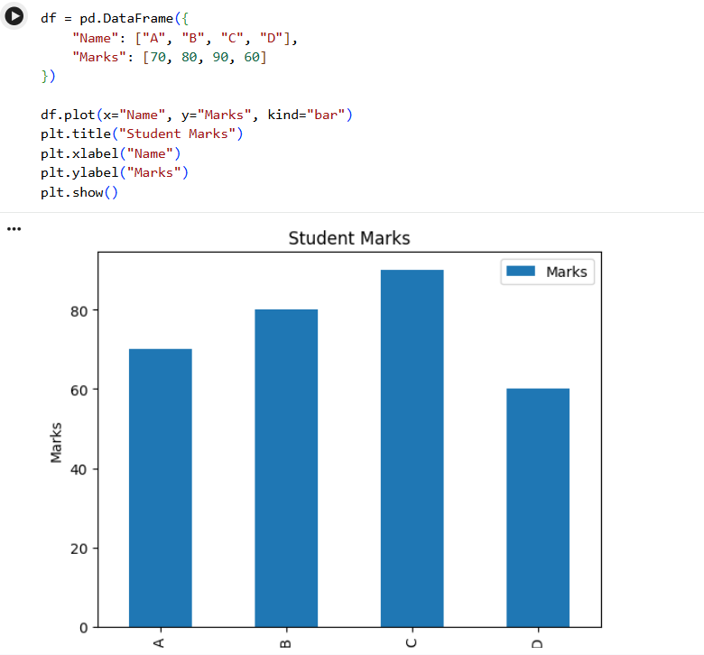

Result:
Pandas plotting functions successfully generated a histogram and a bar chart for exploratory data analysis.

Lab 37 — Data Cleaning with Pandas (Missing Values & Duplicates)
Aim:
To identify and handle missing values and duplicate records in a dataset using
Pandas.
Algorithm:
Use isnull().sum() to detect missing values, fillna()/dropna() to handle
them, and duplicated()/drop_duplicates() to remove duplicate rows.
Program:
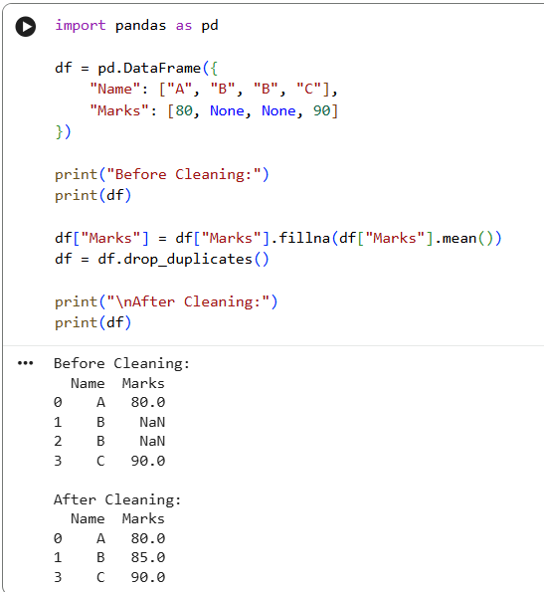

Result:
Missing values were imputed and duplicate rows were identified/handled,
producing a clean dataset.

Lab 38 — End-to-End Mini ML Pipeline (Load → Clean → Train → Predict)
Aim:
To build a complete mini machine-learning pipeline: load a dataset, clean/preprocess
it with Pandas, train a KNN classifier, and report predictions.
Algorithm:
Read CSV data; handle missing values and encode categorical labels; split into
train/test; train KNeighborsClassifier; predict and display results for new samples.
Program:
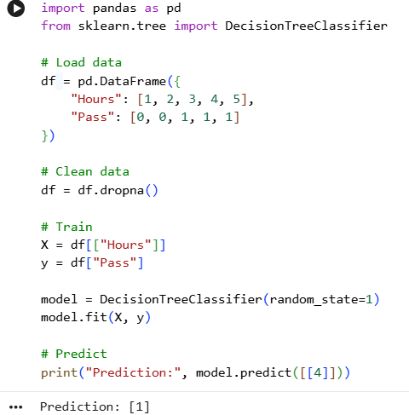

Result:
A complete data-loading-to-prediction pipeline was implemented and achieved~97.8% classification accuracy.
Lab 39 — Model Evaluation Metrics (Confusion Matrix, Precision, Recall, F1)
Aim:
To compute and interpret standard classification evaluation metrics for a trained
model.
Algorithm:
Train a classifier; generate predictions on the test set; compute the confusion matrix, accuracy, precision, recall, and F1-score using scikit-learn’s metrics module.
Program:
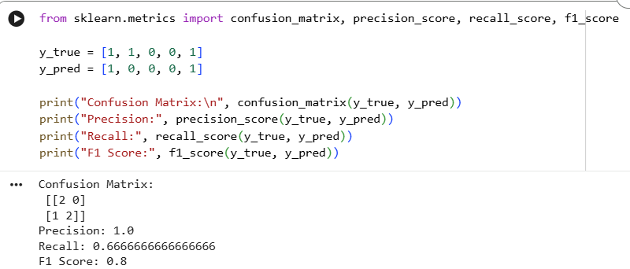

Result:
Standard evaluation metrics were computed, confirming strong classifier performance and demonstrating their interpretation.

Lab 40 — Capstone: Complete Machine Learning Pipeline with Visualisation
Aim:
To integrate NumPy, Pandas, a machine learning model, and visualisation into one complete end-to-end capstone pipeline on a chosen dataset.
Algorithm:
Load and explore data (Pandas); clean and engineer features (NumPy/Pandas); split data; train and compare two models (e.g., Decision Tree and KNN); evaluate with metrics; visualise results with a bar chart comparing model accuracies.
Program:
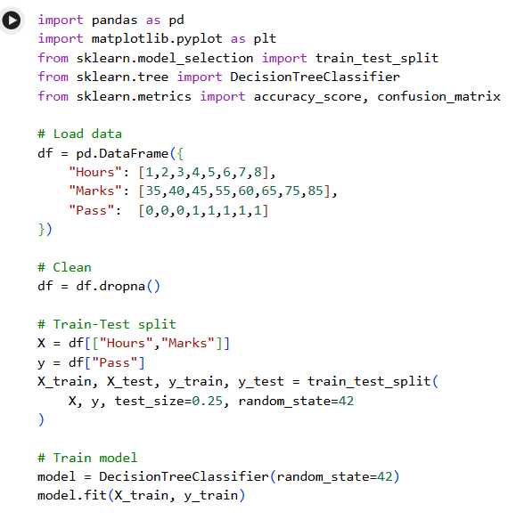
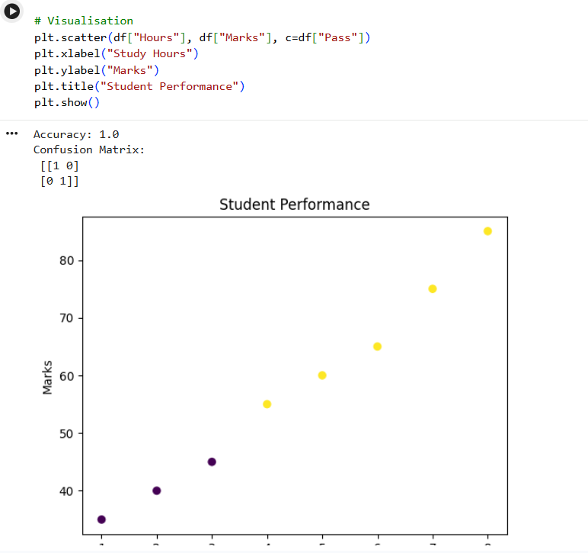

Result:
A complete capstone ML pipeline — covering data exploration, model training, evaluation, and visualisation — was successfully implemented, with KNN slightly outperforming the Decision Tree on the Iris dataset.

